USAAF face hazards of wartime flying

20th February 1943: Alongside combat casualties a high proportion of men were lost in flying accidents
FEB 20

SAVE |  | ▷ LISTEN

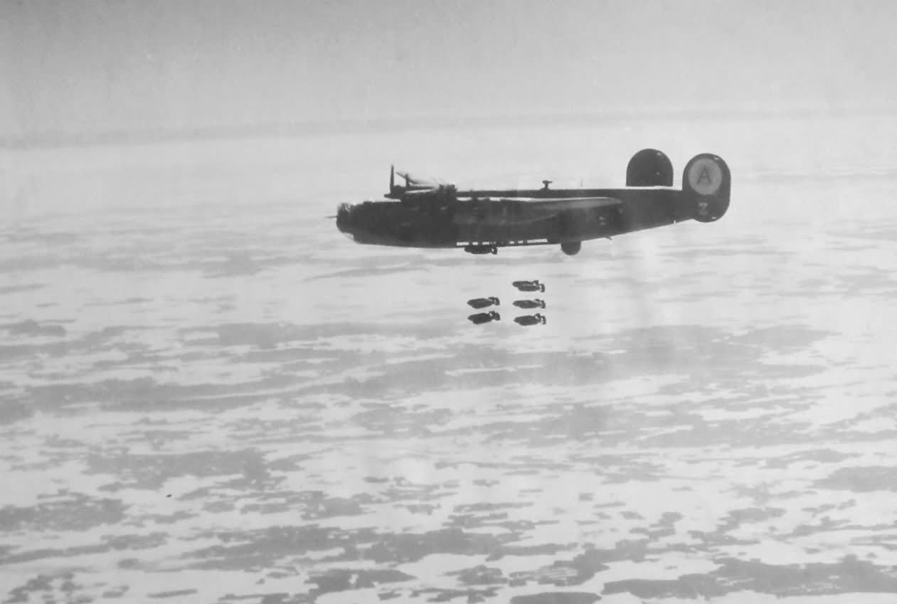
A B-24 Liberator of the 44th Bomb Group later in the war.
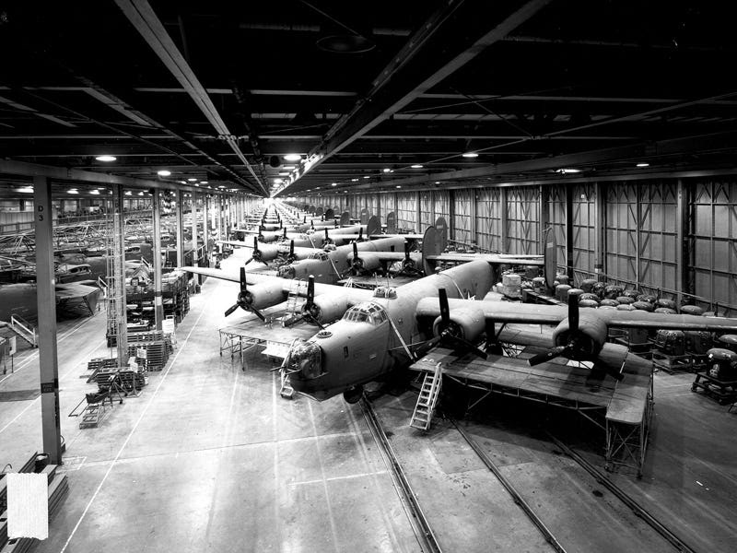
The Ford factory at Willow Run built 8,685 B-24 bombers - 6,792 complete planes and 1,893 knock-down kits - by the time the last one was finished on June 28, 1945. No one had ever manufactured aeroplanes on such a scale before
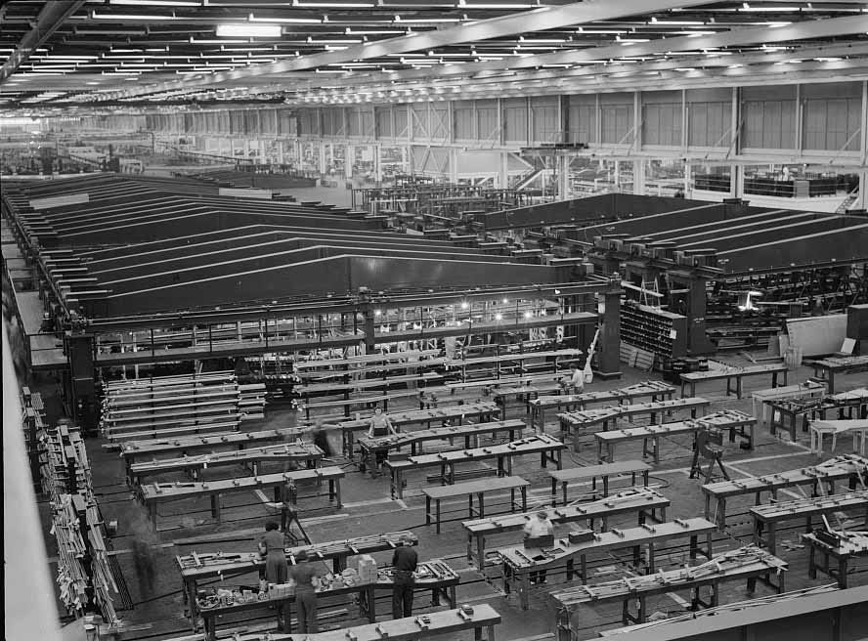
A small part of the world's largest one-story war production plant, the giant bomber factory at Willow Run, Michigan. Fixtures in the background hold bomber wings during assembly, 1942.
There were many hazards faced by Forces personnel in the war, quite apart from the dangers of combat. Necessarily safety regimes were relaxed in wartime and casualties from accidents were high. They were probably highest in the air forces where inherent dangers were multiplied by huge numbers of men being trained on new types of aircraft in relatively short spaces of time.
Of the 55,500 fatal casualties from RAF Bomber Command in the war, 8,195 were killed in flying accidents or ground accidents. These included men of many different nationalities, including American citizens who joined the war before the USA itself.
It has been difficult to find comparable figures for the 8th USAAF which began operating from Britain in 1942 and was just beginning its bombing campaign against Germany and occupied Europe. There were 13,621 fatalities from accidents in all aircraft types in the continent of America alone between 1942-1945, during which 12,506 planes were wrecked.
Aircraft Accidents were, of course, also common on operations overseas. The 20th February 1943 was probably no different from any other practice flying day for the 44th Bomb Group¹, 8th Air Force:
20 February 1943
Practice Flying, Shipdham, England
Lt. Bill McCoy and crew were performing practice flying when the aircraft and crew suddenly crashed in the vicinity of Watton, burning all of the men beyond recognition. As the crew was flying alone and because there were no survivors, very little was learned as to what caused the crash and the resulting disaster. A local English farmer said he heard the aircraft and saw it crash. The entire tail section had broken off.
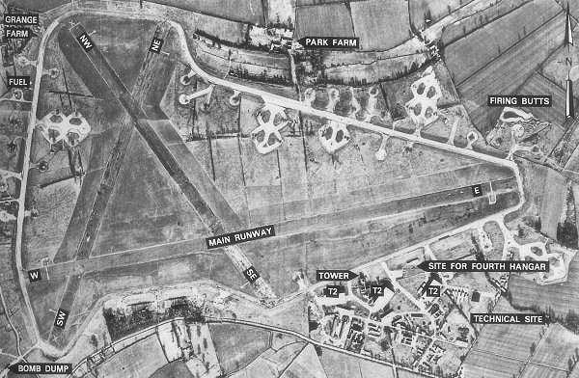
RAF Shipdham was the first US heavy bomber base in Norfolk and was also the continuous host to Consolidated B-24 Liberators longer than any other Eighth Air Force combat airfield in Britain - from October 1942 to late 1945. It was constructed 1941-42 and was assigned USAAF designation Station 115 (SJ).43-02-20
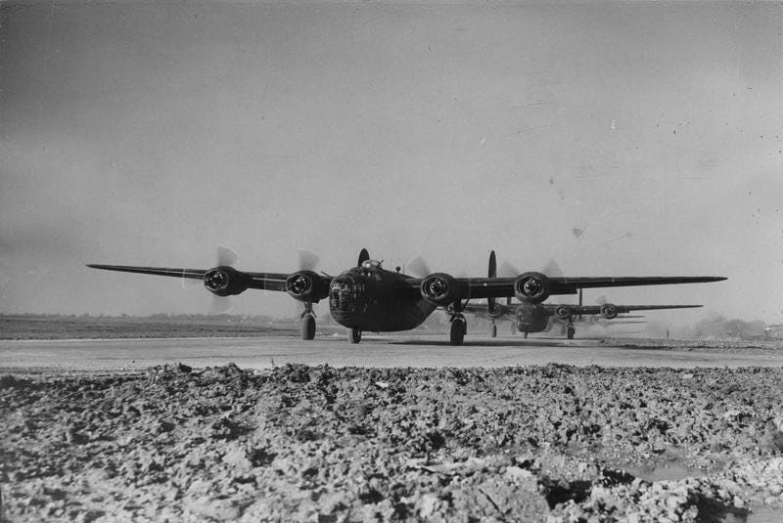
B-24 Liberators of the 44th Bomb Group line up for take-off. Passed for publication 16 February 194
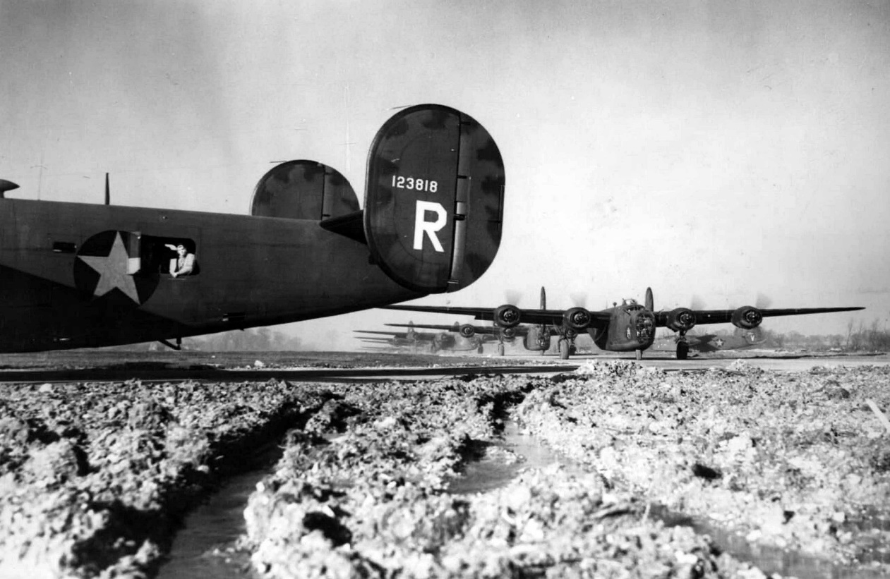
B-24 Liberators of the 44th Bomb Group line up for take off at Shipdham in 1943. A B-24 Liberator (serial number 41-23818) nicknamed "Bela" leads the lineup; one of her waist gunners is at his position.
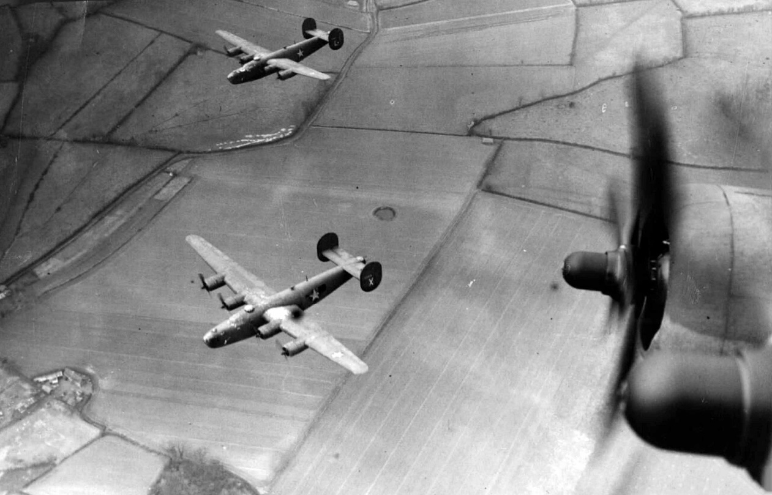
B-24 Liberators of the 44th Bomb Group fly over the countryside. Passed for publication 16 February 194
Fellow pilot Howard Adams² was to remember the accident in his diary:
Last Saturday (February 20th) marked the tragic end of a very tragic week. On that afternoon Capt. Bill McCoy of the 66thk up Lt. Col. Snavely to shoot some landings in Bill’s B-24 SCRAPPIE’S PAPPY as he called it. After several landings they taxied back to the parking area to let the Col. out but Bill said he wanted to shoot some more landings with Jon C. Brown , a bombardier, acting as co-pilot. Twenty minutes after they had taken off the report came in that they had crashed.
Hoping against hope that it wasn’t serious, Bill Brandon and I rushed down to operations only to be crushed by the news that all of the crew, some eight men, had been killed including Bill McCoy, Brown, and Hook, a navigator for a long time in the 66th. Despite the fact that all of the fellows on the ship were swell fellows the lost Bill McCoy was perhaps the hardest blow yet suffered by the squadron or even the group.
Immediately on losing its tail the plane went into a flat spin and dove into the ground at a very high speed killing everyone on impact.
A big six foot two, 200 pounds with curly black hair and a smile a mile wide, ‘Big Bill’ or ‘Wild Bill’ as he was affectionately known, was liked and looked up to by everyone from the colonel to the lowliest private. As a flyer he took second seat to nobody for he was noted for his ability to put a B-24 through its paces. On many of our raids Bill led the whole group and was by far the best of them all at it.
On investigation of the accident it was found that the whole tail assembly had fallen off from Bill’s plane while it was three or four thousand feet up and so it was impossible for even Bill to land her safely. Immediately on losing its tail the plane went into a flat spin and dove into the ground at a very high speed killing everyone on impact. After hitting the ground it burst into flames and so was completely demolished. This accident brought our total losses for the week up to six.
Howard F. Adams was to be killed only a few days later, on the 26th February raid on Wilhelmshaven Naval base, along with all but one of his crew.
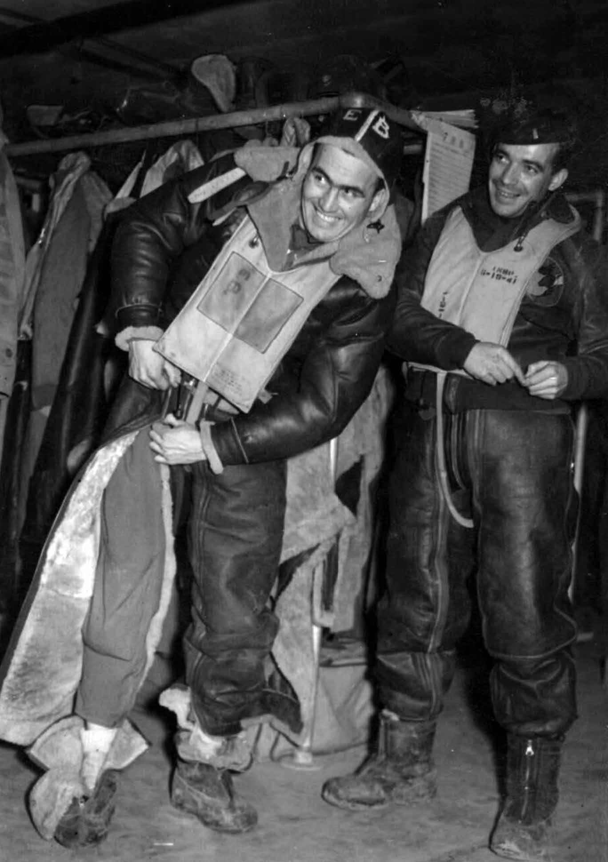
Two airmen of the 44th Bomb Group put on their electrically heated flight suits.
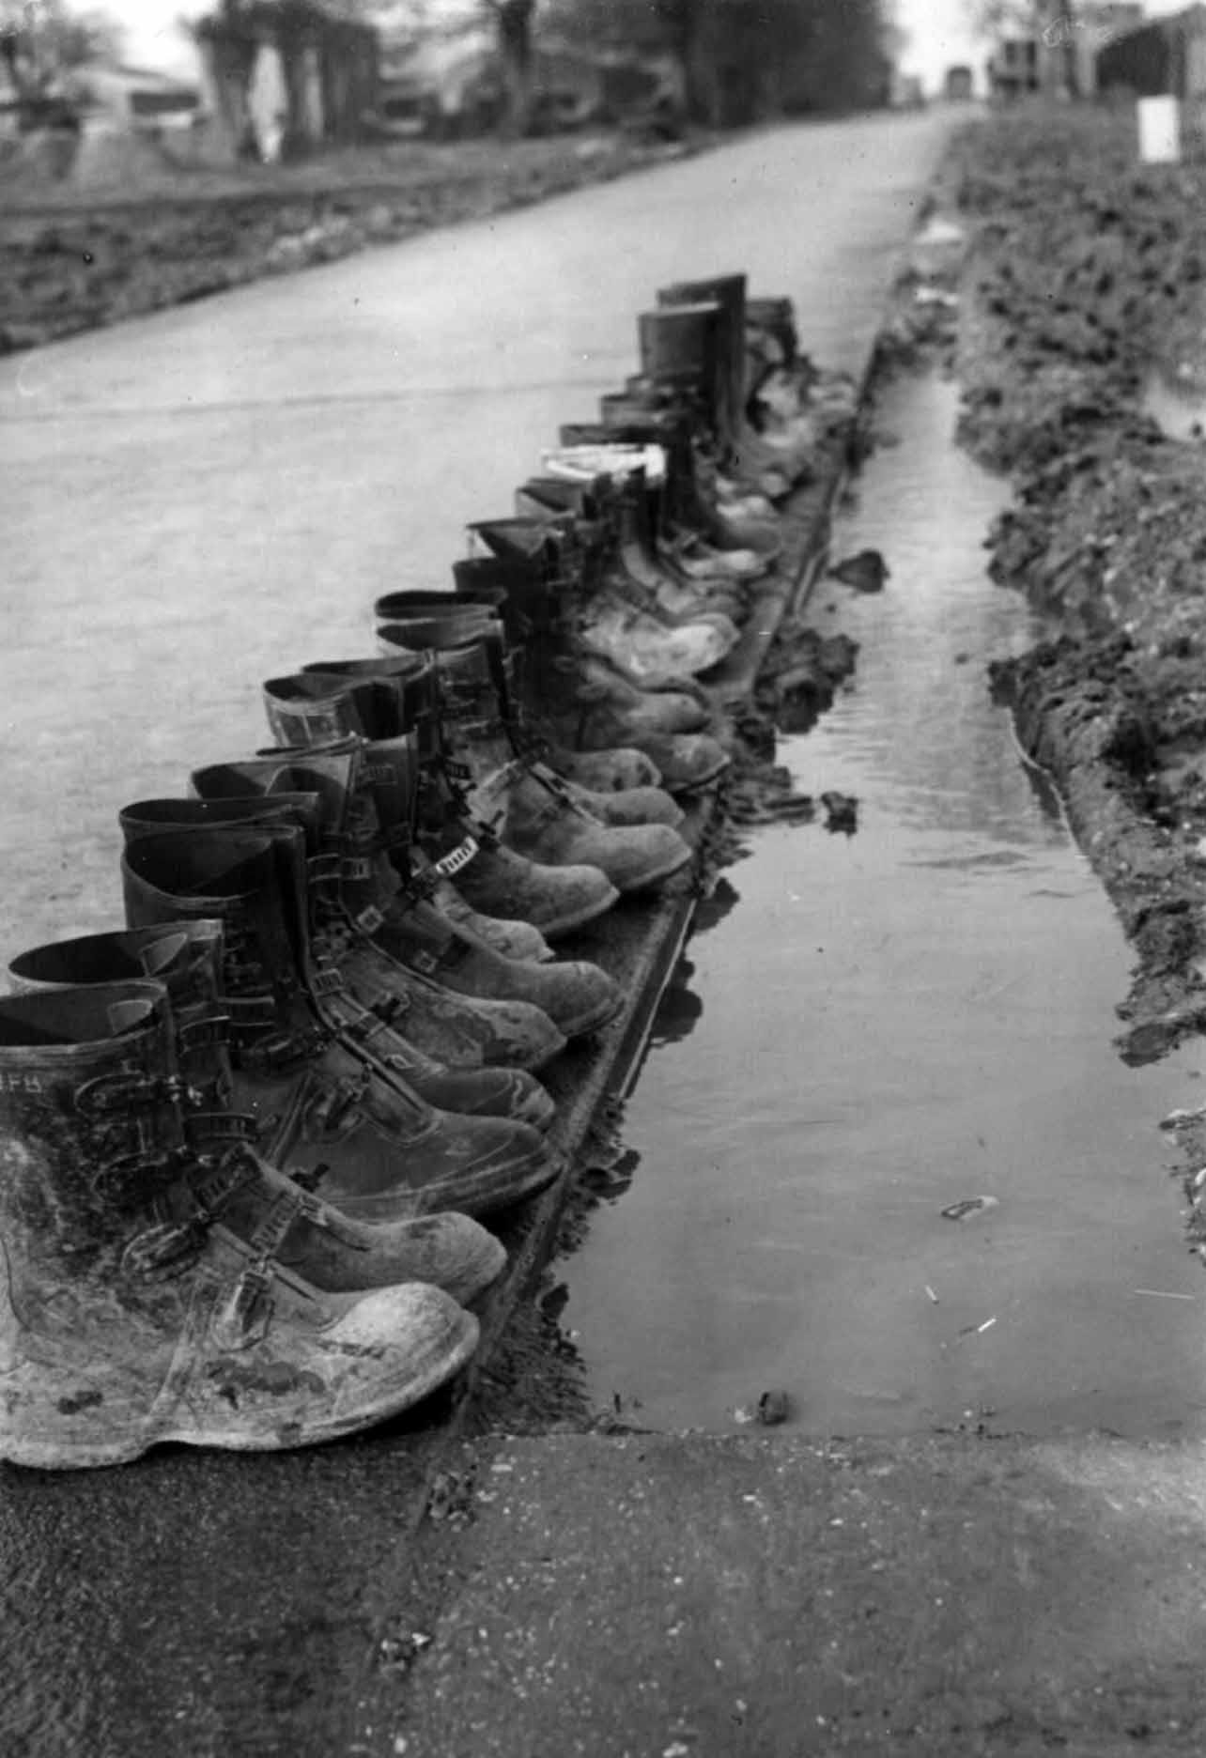
A line of boots belonging to personnel of the 44th Bomb Group.
1
44th Bomb Group Roll of Honor.
2
Full details of the crash are at Aviation-Safety.Net
Crew (all killed):
Capt Bill McCoy (pilot) Los Angeles,California
1st Lt Robert D Hook (navigator) Staten Island, New York
2nd Lt John C Brown (bombardier) Atlanta, Georgia
M/Sgt Allen D Smith (crew chief) McKeesport, Pennsylvania
S/Sgt David W Johnston, Jr. (assistant radio) Gordon, Texas
Sgt Kenneth C Sivertsen (passenger) Clinton, Iowa
Cpl Albert H Berg (passenger) Seattle, Washington
Cpl Walter Binienda (passenger) Auburn, Massachusetts

